2013年12月大学英语四级真题
作文
请于正式开考后半小时内完成该部分，之后将进行听力考试
作文一：
For this part,you are allowed 30 minutes to write a short essay based on the picture below.
You should start your essay with a brief account of the impact of the Internet on the way people communicate and then explain whether electronic communication can replace face-to-face contact.You should write at least 120 words but no more than 180 words.
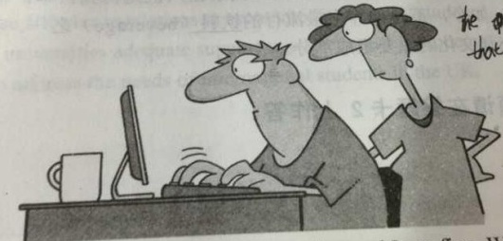
“Dear Andy-How are you? Your mother and I are fine.We both miss you and hope you are doing well.We look forward to seeing you again the nest time your computer crashes and you come down-stairs for something to eat,Love,Mom and Dad.”

作文二：
For this part,you are allowed 30 minutes to write a short essay based on the picture below.
You should start your essay with a brief account of the impact of the Internet on learning and then explain why
doesn’t simply mean learning to obtain information. You should write at least 120 words but no more than 180 words.
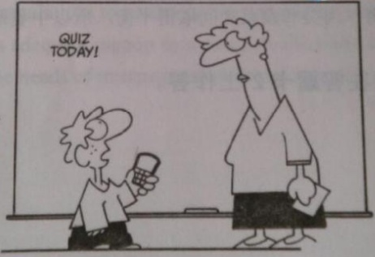
“Once I learn how to use Google,isn’t that all the education I really need?”

作文三：
For this part,you are allowed 30 minutes to write a short essay based on the picture below.
You should start your essay with a brief account of the increasin,use of the mobile phone in people’s life and explain the
Consequence of overusing it. You should write at least 120 words but no more than 180 words.
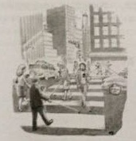
People are crossing the street looking at their cell phones and using walking sticks in order to see.

Part II Listening Comprehension (30 minutes)
Section A
Directions:In this section,you will hear 8 short conversations and 2 long conversations.At the end of each conversation,one or more questions will be asked about what was said.Both the conversation and the questions will be spoken only once.After each question there will be a pause.During the pause,you must read the four choices marked A),B),C)and D),and decide which is the best answer,Then mark the corresponding letter on Answer Sheet 1 with a single line through the centre.
注意：此部分试题请在答题卡1上作答。
1.A)Go to a place he has visited
B)Make her own arrangements
C)Consult a travel agent
D)Join in a package tour
2.
A)They are on a long trip by car
B)They are syuck in a traffic jam
C)They are used to getting up early
D)They are tired of eating out at night
3.
A)He is a person difficult to deal with
B)He dislikes any formal gathering
C)He is unwilling to speak in public
D)He often keeps a distance from others
4.
A)Work in another deparment
B)Pursue further education
C)Recruit graduate students
D)Take an administrative job
5.
A)He would not be available to start the job in time
B)He is not quite qualified for the art director position
C)He would like to leave some more time for himself
D)He will get his application letter ready before May1
6.
A)Cleaner
B)porter
C)Mechanic
D)Salesman
7.
A)Reqest one or two roommates to do the cleaning
B)Help Laura with her term paper due this weekend
C)Get Laura to clean the apartment herself this time
D)Ask Laura to put off the cleaning until another week
8.
A) A problem caused by the construction
B)An accident that occurred on the bridge
C)The building project they are working on
D)The public transportaion conditions

Questions 9 to 11 are based on the conversation you have heard.

9
A) To look for a job as a salesperson
B) To have a talk with Miss Thompson.
C) To place an order for some products.
D) To complain about a faulty appliance.

10
A) The person in charge is not in the office.
B) The supplies are out of stock for the moment.
C) They failed to reach an agreement on the price.
D) The company is re-cataloguing the items.

11
A) 0743,12536 extension 15.
B) 0734,38750 extension 15.
C) 0734,21653 extension 51.
D) 0734,62135 extension 51.

Questions 12 to 15 are based on the conversation you have just heard.

12
A)Since he found a girlfriend
B)Since he took to heavy smoking.
C)Since he began to exercise regularly
D)Since he started to live on his own.
13
A)He is getting too fat.
B)He smokes too much
C)He doesn’t eat vegetables.
D)He doesn’t look well at all.
14
A)They are overweight for their age
B)They are respectful to their parents
C)They are still in their early twenties
D)They dislike doing physical exercise.

15
A)To quit smoking.
B)To find a girlfriend
C)To reduce his weight
D)To follow her advice.

Section B
Directions: In this section, you will hear 3 short passages. At the end of each passage, you will hear some questions. Both the passage and the questions will be spoken only once. After you hear a question, you must choose the best answer from the four choices marked A), B), C) and D). Then mark the corresponding letter on Answer Sheet 1 with a single line through the centre.

注意：此部分试题请在答题卡1上作答。
Passage One
Questions 16 to 19 are based on the passage you have just heard.

16.
A)They have destroyed several small towns.
B)They will soon spread to San Francisco.
C)They have injured many residents.
D)They are burning out of control.
17.
A) They have been hospitalized.
B) They have got skin problems.
C) They were choked by the thick smoke.
D) They were poisoned by the burning chemicals.
18.
A)It failed because of a sudden rocket explosion.
B) It has been re-scheduled for a midday takeoff.
C) It has been canceled due to technical problems.
D) It was delayed for eleven hours and thirty minutes.
19.
A)They made frequent long-distance calls to each other.
B) They illegally used government computers in New Jersey.
C) They were found to be smarter than computer specialists.
D) They were arrested for stealing government information.
Passage Two
Questions 20 to 22 are based on the passage you have just heard.
20.
A)Peaceful
B)Considerate
C)Generous
D)Cooperative
21.
A)Someone dumped the clothes left in the washer and dryer.
B)Someone broke the washer and dryer by overloading them.
C)Mindy Lance’s laundry blocked the way to the laundry room.
D)Mindy Lance’s threatened to take revenge on her neighbors.
22.
A)Asking the neighborhood committee for help.
B)Limiting the amount of laundry for each wash.
C)Informing the building manager of the matter.
D)Installing a few more washers and dryers.
Passage Three
Questions 23 to 25 are based on the passage you have just heard.
23.A) She is both a popular and a highly respected author.
B) She is the most loved African novelist of all times.
C) She is the most influential author since the 1930's.
D) She is the first writer to focus on the fate of slaves.

24. A) The Book Critics Circle Award.
B) The Pulitzer Prize for fiction
C) The Nobel Prize for literature.
D) The National Book Award.

25. A)She is a relative of Morrison's.
B) She is a skilled storyteller.
C) She is a slave from Africa.
D) She is a black woman

Section C
Directions: In this section, you will hear a passage three times. When the passage is read for the first time，you should listen carefully for its general idea.When the passage is read for the second time，you are required to fill in the blanks with the exact words you have just heard. Finally，when the passage is read for the third time，you should check what you have written.
注意：此部分试题请在答题卡1上作答。

Many college students today own personal computer that cost anywhere from $1,000 to perhaps %5,000 or more. (26)_________, it is not uncommon for them to purchase (27)_________costing another several hundred dollars. Twenty years ago, computers were (28) ___________, but they were very large and extremely expensive. Few, if any,(29) __________ purchased computers for home use. Over the years, the price of the “guts” of a computer---its memory—has declined to less than a thousandth of the price per unit of memory that prevailed twenty years ago. This is the main reason why computers cost so much less today than they used to. Moreover, (30) _________improvements have made it possible to (31) ___________memory circuitry that is small enough to fit into the portable personal computers that many of us own and use. (32)___________, as the price of computation has declined the average consumer and business have spent more on purchasing computers.
(33)___________,improved agricultural technology, hybrid(杂交) seeds,(34)_________animal breeding, and so on have vastly increased the amount of output a typical farmer can produce. The prices of goods such as meats and grains have fallen sharply relative to the prices of most other goods and services. As agricultural prices have fallen, many households have decreased their total expenses on food. Even though the (35)______________of a product purchased generally increases when its price falls, total expenses on it may decline.

翻译一
Part IV Translation
Directions : For this part,you are allowed 30 minutes to translate a passage from Chinese into English.You should write your answer on Answer Sheet 2
许多人喜欢中餐。在中国，烹饪不仅被视为一种技能，而且也被视为一种艺术。精心准备的中餐既可口又好看。烹饪技艺和配料在中国各地差别很大。但好的烹饪都有一个共同点，总是要考虑到颜色、味道、口感和营养（nutrition）。由于食物对健康至关重要，好的厨师总是努力在谷物、肉类和蔬菜之间取得平衡，所以中餐既味美又健康。
注意：此部分试题请在答题卡2上作答。

翻译二
Part IV Translation
Directions : For this part,you are allowed 30 minutes to translate a passage from Chinese into English.You should write your answer on Answer Sheet 2
"你要茶还是咖啡？"是用餐人常被问到的问题，许多西方人会选咖啡，而中国人则会选茶，相传，中国的一位帝王于五千年前发现了茶，并用来治病，在明清（the qing dynasties）期间，茶馆遍布全国，饮茶在六世纪传到日本，但直到18世纪才传到欧美，如今，茶是世界上最流行的饮料（beverage）之一，茶是中国的瑰宝。也是中国传统和文化的重要组成部分。

翻译三
Part IV Translation
Directions : For this part,you are allowed 30 minutes to translate a passage from Chinese into English.You should write your answer on Answer Sheet 2
信息技术（Information Technology），正在飞速的发展，中国公民也越来越重视信息技术，有些学校甚至将信息技术作为必修课程，对这一现象大家持不同观点。一部分人认为这是没有必要的，学生就应该学习传统的课程。另一部分人认为这是应该的，中国就应该与时俱进。不管怎样，信息技术引起广大人民的重视是一件好事。
翻译四
Part IV Translation
Directions : For this part,you are allowed 30 minutes to translate a passage from Chinese into English.You should write your answer on Answer Sheet 2
中国结最初是由手工艺人发明的，经过数百年不断的改进，已经成为一种优雅多彩的艺 术和工艺。在古代，人们用它来记录事件，但现在主要是用于装饰的目的。“结”在中文里意味这爱情丶婚姻和团聚，中国结常常作为礼物交换或作用饰品祈求好运 和辟邪。这种形式的手工艺代代相传，现在已经在中国和世界各地越来越受欢迎。

